DSA Part 1 BFS
#include <iostream>
using namespace std;

class Queue {
private:
int arr[50];
int front;
int rear;
public:
Queue() {
front = 0;
rear = -1;
}

bool isEmpty() {
return front > rear;
}

void enqueue(int val) {
if (rear < 49) {
rear++;
arr[rear] = val;
} else {
cout << "Queue is full!" << endl;
}
}

int dequeue() {
if (!isEmpty()) {
int val = arr[front];
front++;
return val;
} else {
return -1;
}
}
};

int main() {
int n, e;
cout << "Enter number of web pages (max 10): ";
cin >> n;

int adj[10][10] = {0};

cout << "\nEnter number of hyperlinks: ";
cin >> e;

cout << "\nEnter links (from to):\n";
for (int i = 0; i < e; i++) {
int from, to;
cin >> from >> to;
adj[from][to] = 1;
}

int start;
cout << "\nEnter seed/start page number: ";
cin >> start;

bool visited[10] = {false};
Queue q;

cout << "\n\nIndexing pages starting from: " << start << endl;

visited[start] = true;
q.enqueue(start);

while (!q.isEmpty()) {
int current = q.dequeue();
cout << "\nIndexed page: " << current;

for (int i = 0; i < n; i++) {
if (adj[current][i] == 1 && !visited[i]) {
visited[i] = true;
q.enqueue(i);
}
}
}

cout << endl;
return 0;
}

Output:-
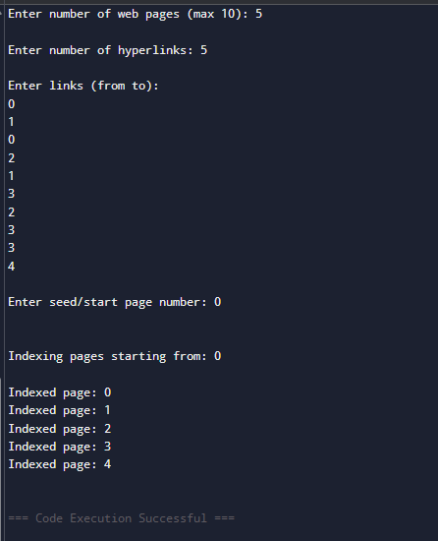

Part B :DFS
#include <iostream>
using namespace std;

class Stack {
private:
int arr[50];
int top;
public:
Stack() { top = -1; }

bool isEmpty() { return top == -1; }

void push(int val) {
if (top < 49) {
top++;
arr[top] = val;
} else {
cout << "Stack is full!" << endl;
}
}

int pop() {
if (!isEmpty()) {
int val = arr[top];
top--;
return val;
} else {
return -1;
}
}
};

int main() {
int n, e;
cout << "Enter number of web pages (max 10): ";
cin >> n;

int adj[10][10] = {0};

cout << "\nEnter number of hyperlinks: ";
cin >> e;

cout << "\nEnter links (from to):\n";
for (int i = 0; i < e; i++) {
int from, to;
cin >> from >> to;
adj[from][to] = 1;
}

int start;
cout << "\nEnter seed/start page number: ";
cin >> start;

bool visited[10] = {false};
Stack s;

cout << "\n\nIndexing pages starting from: " << start << endl;

s.push(start);

while (!s.isEmpty()) {
int current = s.pop();

if (!visited[current]) {
visited[current] = true;
cout << "\nIndexed page: " << current;

for (int i = n - 1; i >= 0; i--) {
if (adj[current][i] == 1 && !visited[i]) {
s.push(i);
}
}
}
}

cout << endl;
return 0;
}

Output:-
